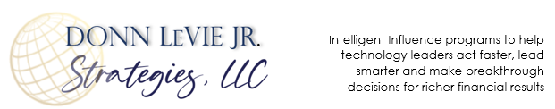
PERMISSION TO REPRINT ARTICLES FROM
DONN LeVIE JR. 24/7 EDITOR RESOURCE PAGE
Permission (non-exclusive) to reprint articles by Donn LeVie Jr. is hereby given to all print, broadcast and electronic media provided that the contact information at the end of each article is included in your publication. For organizations publishing articles electronically, a live, clickable link to https://www.donnleviejrstrategies.com must also be included with the body of the article.
Additionally, please mail one copy of your publication to:
Donn LeVie Jr. STRATEGIES, 6329 Clarion Drive, Austin, Texas 78749.
- Permission to reprint articles by Donn LeVie Jr. at no charge is granted with the agreement that:
  - The article bio be included following each article used.
  - One copy of the publication in which the article is published be provided to Donn LeVie Jr. STRATEGIES.
  - A $300 fee (per article) will be expected for articles published without the closing bio and contact information.
  - All articles © Copyright 2021 Donn LeVie Jr./Donn LeVie Jr. STRATEGIES, LLC.
- Permission is also granted for reasonable:
  - Editing content and industry-specific example exchange
  - Word length
  - Article title change
- Electronic publishing of articles must include a live, clickable link to https://www.donnleviejrstrategies.com.

Any questions, please email to donn@donnleviejrstrategies.com

Annual Employee Assessments:

What Leaders Should Know About Their Limitations
Donn LeVie Jr. / Donn LeVie Jr. STRATEGIES, LLC
The phrase “working in a sausage factory” suggests that the details of how sausage is made may be undesirable; however, the end product is all that concerns us. This phrase is used by workers in many industries to describe in a tongue-in-cheek manner a company’s internal operations. The same can be said for assessing employee job performance – we’re really only interested in the outcome of those evaluations.
Study after study has revealed that there’s little correlation between how peers review each other and how their manager’s review them individually. Yet, those results get fed into the HR or corporate sausage grinder annually by thousands of companies. Those results are used to reward or remove employees on the far ends of the old-school bell curve (“normal distribution” in statistical analysis lingo). See Figure 1 for an illustration of a normal distribution.
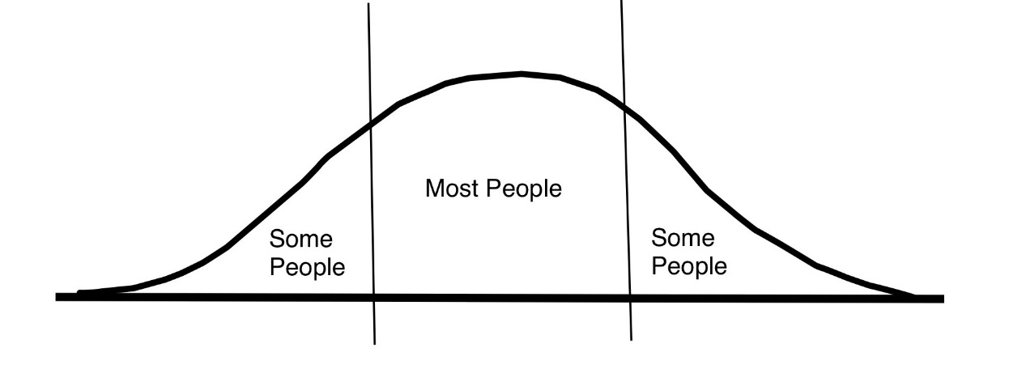

Figure 1. Example of Normal Distribution (Bell Curve)

It’s conceivable that someone who receives more than one or two promotions or transfers within a twelve-month period, or someone who works in a collaborative team environment may be at a ratings disadvantage (subject to more layers of bias) compared to those who have remained in one position or work as individual contributors during that same period. Companies that still embrace the bell-curve paradigm make huge upstream assumptions about evaluation instruments used to derive those results.
Psychometric rating theory states that any employee rating accuracy depends on employee performance, the manager’s perception of the employee’s performance, and how well the manager recalls performance observations. But it’s not that simple.
Classical mental test theory developed in the early 1950s states that individual rating criteria introduce some degree of bias and environmental influence, while random error is ever present with nearly all such performance rating approaches. The concern here is that placing too much reliability in such employee rating results may reflect manager bias more so than an accurate accounting of actual performance.
What should be of greater concern is how accurate and valid as well as reliable those results are, as Figure 2 illustrates.

Accurate and Reliable
Inaccurate and Reliable
Figure 2. Accurate and Reliable vs. Inaccurate and Reliable

Force-fit ratings, like the normal distribution, often stifle innovation and risk-taking by employees for fear of being stuffed into the “needs improvement” portion of the bell curve (or worse). If people fear taking informed risks for fear of the annual retribution it may bring, then what you have is a company full of employees performing their stated job duties, but who could otherwise be game changers, problem solvers, and solutions providers.
Here are a few ideas for leaders to consider during performance review time:
Inaccurate and Reliable
- There’s no such thing as a “5-star” employee in all categories; everyone has at least one area that needs further development in their professional specialty, relationship skills with peers/management/members, or communications skills with peers/management/members.
- The danger in making everyone a star performer (beware “the talent”) is that it provides a false snapshot of the “health” of the organization by elevating employee contributions/performance to an unrealistic level, thereby masking areas that truly require additional attention or development. It’s the equivalent of giving every kid a trophy on the soccer team for “participation.” Enron, WorldCom, and Tycho were run by so-called “big talent” who began prioritizing personal interests and gain over that of the company and shareholders.
- The annual performance review is just as much a way to determine where things need to be shored up in the system and with poor performers as it is to reward those whose performance exceeds the duties and responsibilities of their respective position.
- Annual reviews must be performed in the absence of any relationship attachment to the person being reviewed, otherwise the conditions for favoritism can ferment and create a tendency to evaluate someone higher (or lower) based on that relationship. This is one reason why there must be a respectful and conscious relationship “distance” between manager and subordinate.
- Managers must resist the temptation to place too much weight on one minor negative encounter. Overemphasis on the negative is sometimes seen by inexperienced or poor managers during annual reviews or opportunities for promotion whereby one minor disagreement or issue overshadows all the positive contributions a candidate made during the year.
Basically, the annual performance review (with quarterly course corrections and documented) is an opportunity to identify those invisible or subdued issues or deficiencies that need correction so that the true health of the organization can be assessed and corrected, where necessary. Everyone benefits from this approach. Go into the annual review process looking for behaviors and results in need of addressing or improvement as well as behaviors and results in need of praise with equal vigor.

§§
Engagement and positioning strategist, leadership platform expeditor, author, and conference speaker Donn LeVie Jr. has 30 years’ experience leading people and projects for such Fortune 100 companies as Phillips Petroleum, Motorola, Intel Corporation; government agencies (NOAA), and academia (Department of Natural Sciences and Mathematics, University of Houston Downtown College). Donn specializes at the intersection of leadership, communication, and performance, which means he works with organization leaders and executives through the doorway of coaching and consulting. Contact Donn at donn@donnleviejrstrategies.com.

